PRATIK RATHI

**Q1)**

In Stackdriver Logging, at the top of Log Exports page, select on Create export  
Click on Edit Export  
Enter the Sink name, service and destination  
 In Sink Service, we select a destination service, here we click on BigQuery  
 In Sink Destination, select or create the particular dataset to receive the exported logs.  
Click on Update Sink to create a sink  
  
To view the logs in BigQuery-

GO to BigQuery UI  
Select the dataset used as the sink's destination  
Select one of the dataset's tables.

The log entries are visible on the Details tab.

**Q2)**

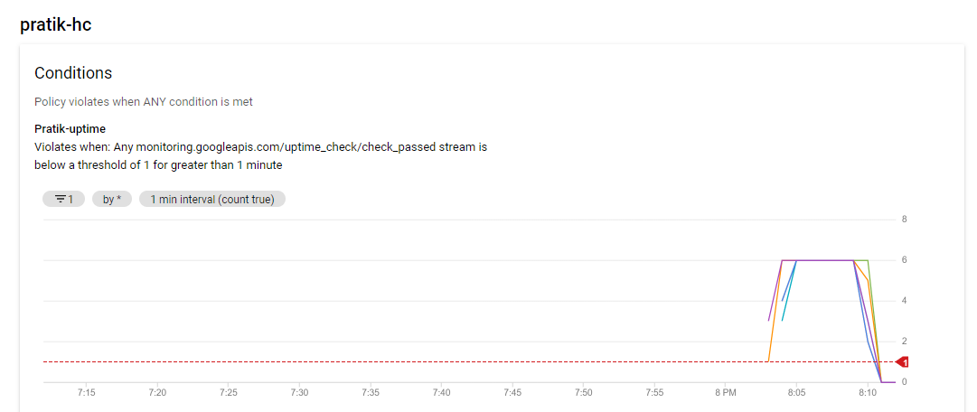

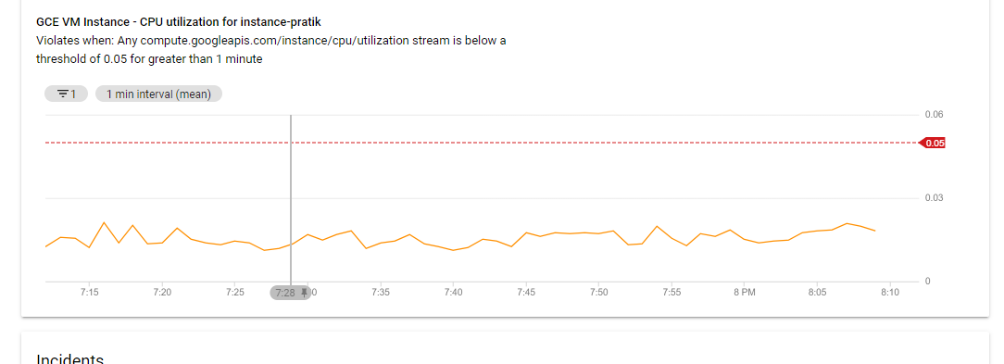

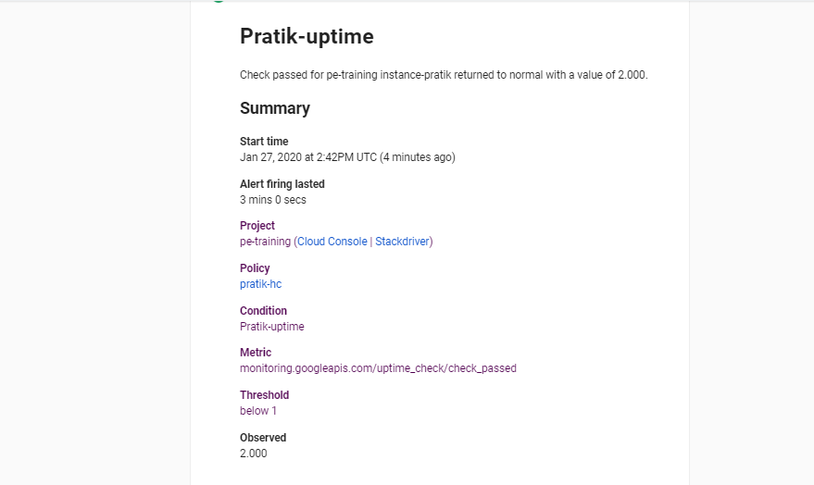

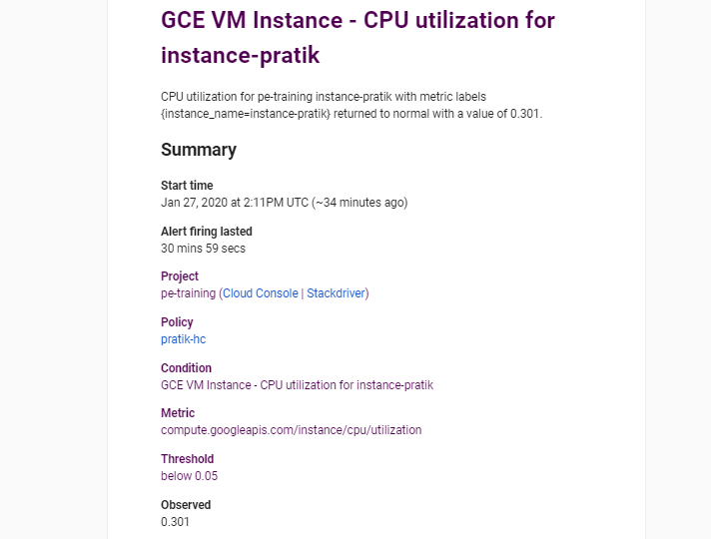

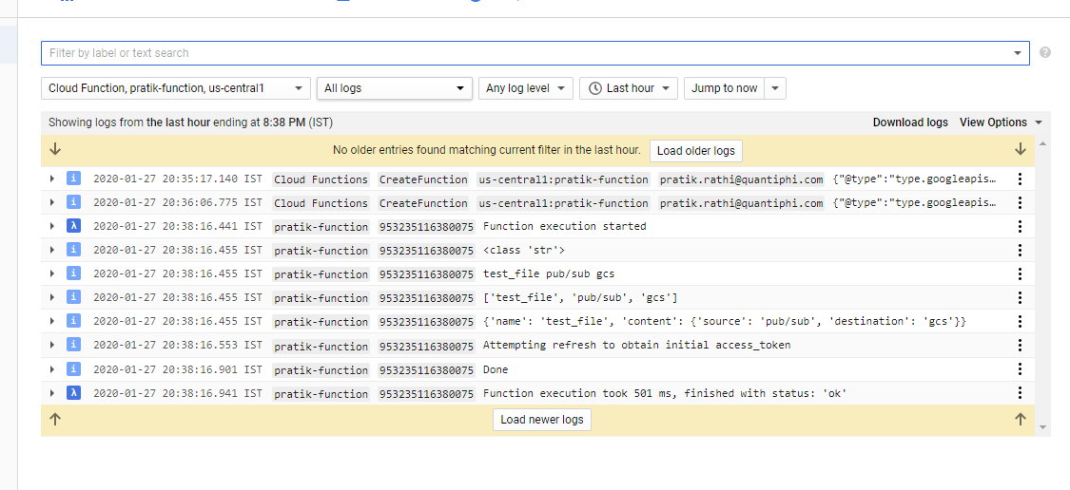

Q3)

